Caroline Morris
The College Funding Coach®
703-394-7112
cmorris@thecollegefundingcoach.org
1593 Spring Hill Road, Suite 520E, Vienna, Virginia 22182
TheCollegeFundingCoach.org

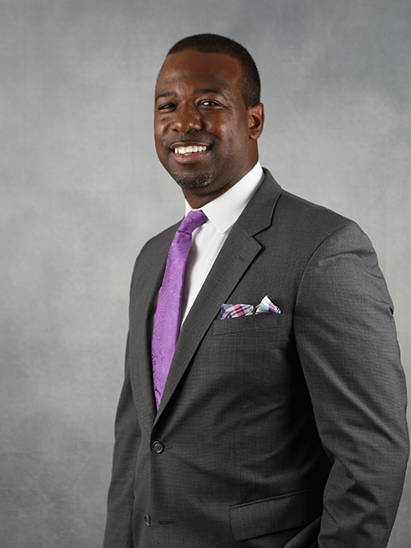

Demetrius Doss
The College Funding Coach®
703-340-6911
ddoss@thecollegefundingcoach.org
1593 Spring Hill Road, Suite 520E, Vienna, Virginia 22182
TheCollegeFundingCoach.org

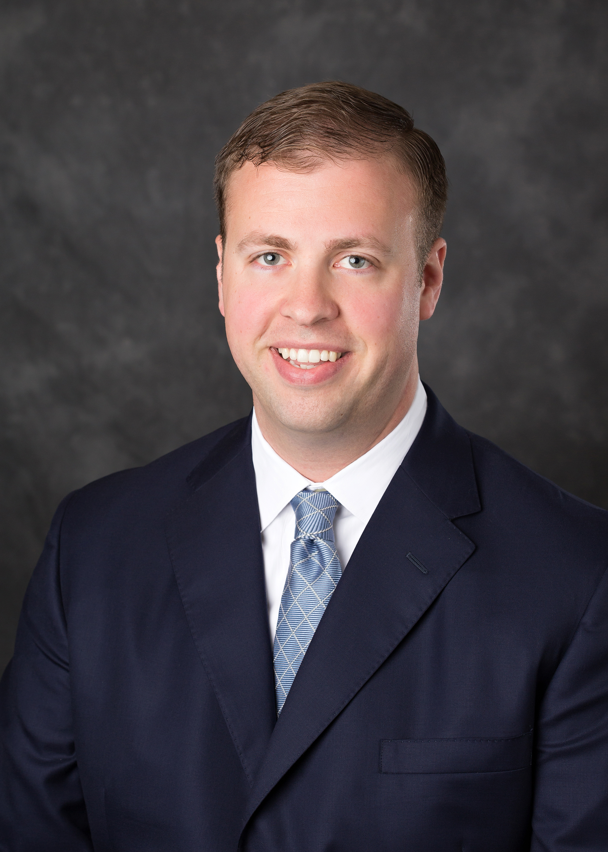

Brock Jolly
The College Funding Coach®
703-424-2401
bjolly@thecollegefundingcoach.org
1593 Spring Hill Road, Suite 500E, Vienna, Virginia 22182
TheCollegeFundingCoach.org

Andrea B. Ashton
The College Funding Coach®
Phone: (703) 430-0789 | Fax: (703) 991-7762 | Mobile: (703) 624-4082
aashton@thecollegefundingcoach.org
1593 Spring Hill Road, Suite 500E, Vienna, Virginia 22182
TheCollegeFundingCoach.org

